**Experiment No. 3**

**Title:**

Working in Cloud9 to demonstrate different language.

**Objective:**

To learn Platform as service (PaaS) using Free trial of Cloud9 in AWS, because firstly it was an independently platform now it is integrated with AWS.

**Tools used:**

Internet, AWS, EC2, Cloud9

**Prerequisite:**

Understanding of Platform as service in Service model of cloud computing

**Theory:**

AWS Cloud9 is an integrated development environment, or *IDE*.

The AWS Cloud9 IDE offers a rich code-editing experience with support for several programming languages and runtime debuggers, and a built-in terminal. It contains a collection of tools that you use to code, build, run, test, and debug software, and helps you release software to the cloud.

You access the AWS Cloud9 IDE through a web browser. You can configure the IDE to your preferences. You can switch color themes, bind shortcut keys, enable programming language-specific syntax coloring and code formatting, and more.

An *AWS Cloud9 environment* is a place where you store your project's files and where you run the tools to develop your applications.

Using the AWS Cloud9 IDE, you can:

* Store your project's files locally on the instance or server.
* Clone a remote code repository—such as a repo in AWS Code Commit—into your environment.
* Work with a combination of local and cloned files in the environment.

**Steps to setting up the cloud9**

**Step 1. Sign in to the Console <https://aws.amazon.com/console/>**

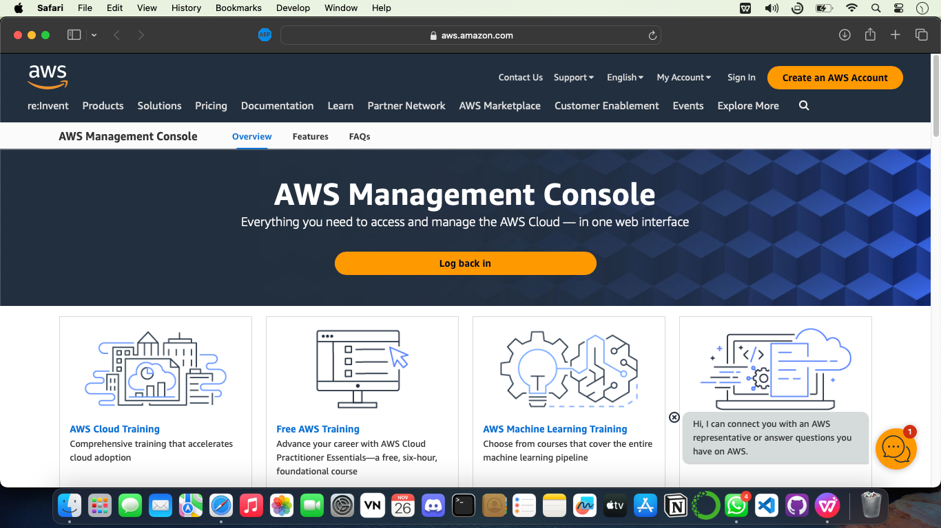

**Step 2. Create EC2 instance and Launch it**

* **Log in to your AWS Management Console.**
* **Go to the EC2 dashboard and click on the "Launch Instance" button.**
* **Choose an Amazon Machine Image (AMI) for your instance.**
* **Select an instance type and configure instance details like network settings, storage, and tags.**
* **Create a new key pair**
* **Configure security groups to control inbound and outbound traffic.**
* **Review your instance settings and launch the EC2 instance.**
* **Create or use an existing key pair for secure access to your instance.**
* **Access your EC2 instance using SSH (Secure Shell) or other remote access methods.**

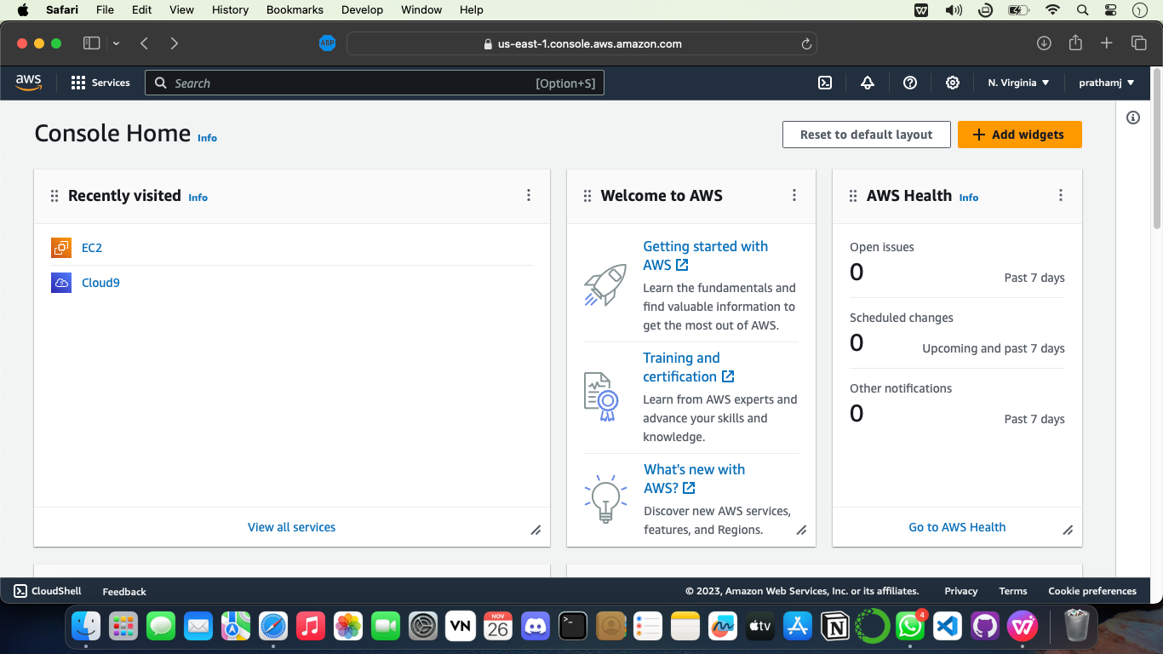

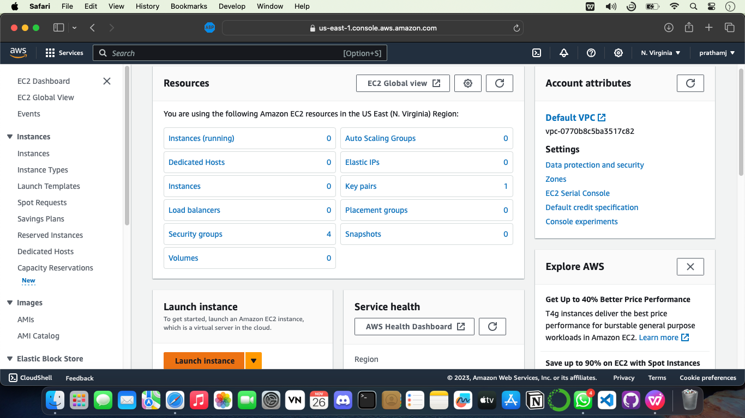

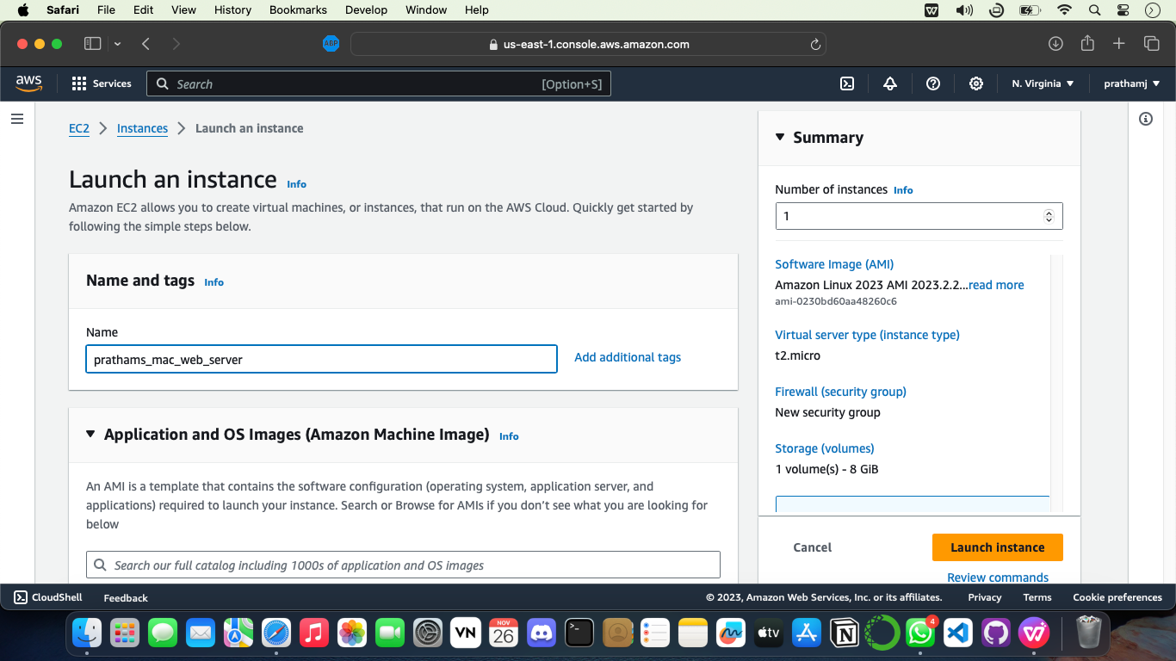

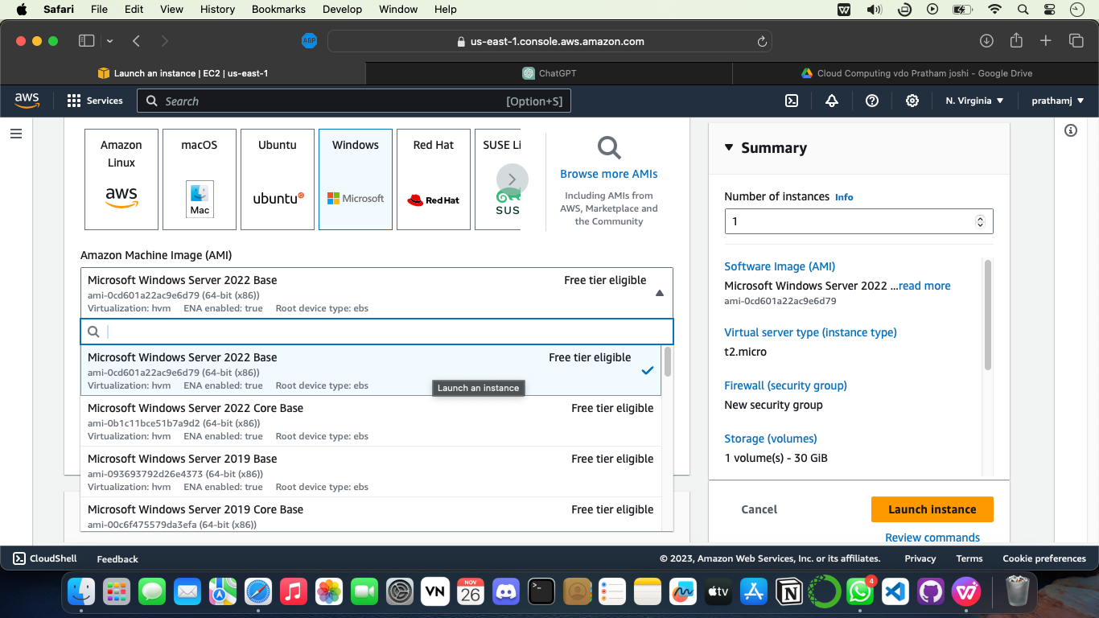

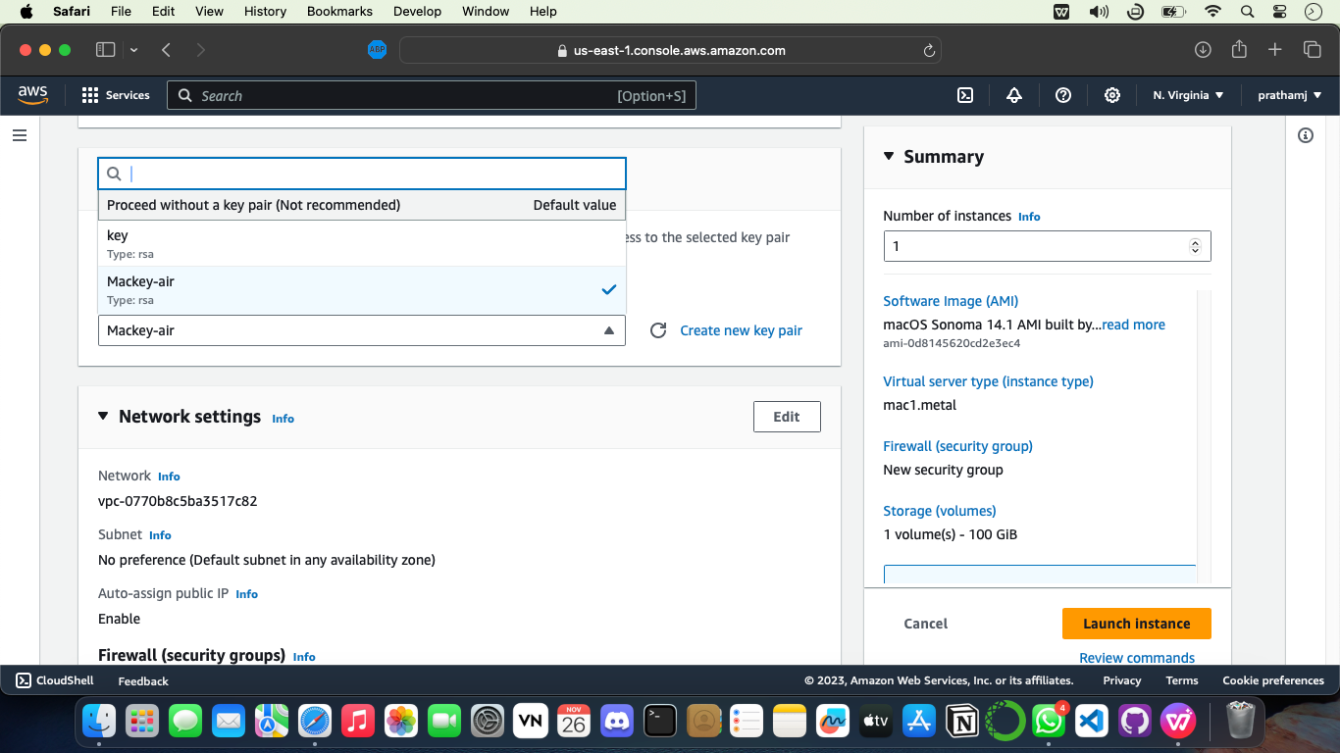

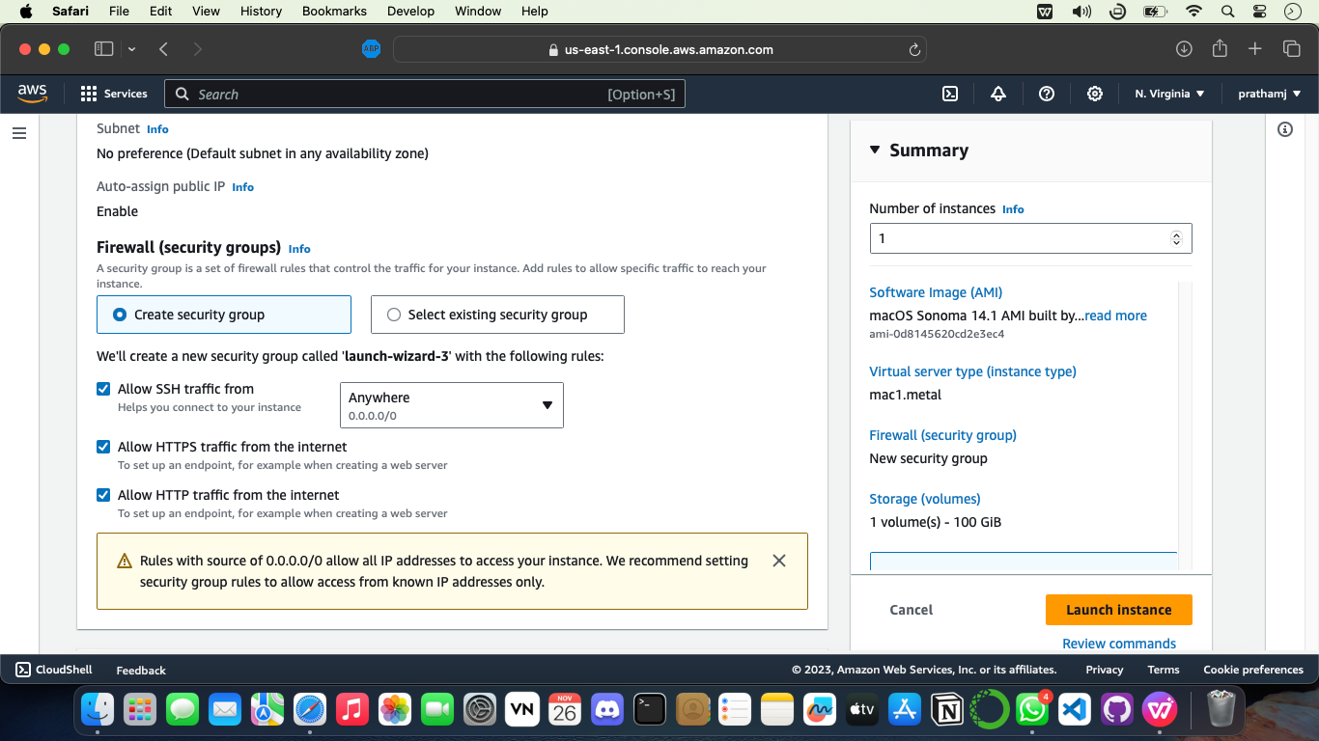

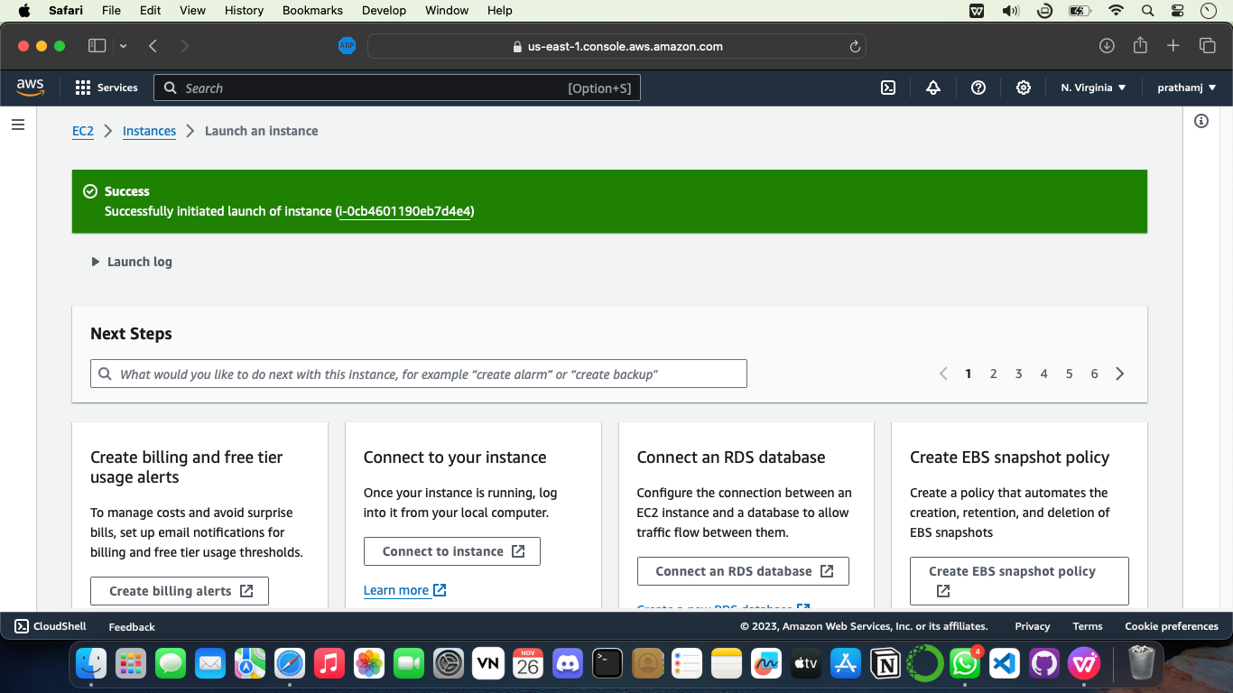

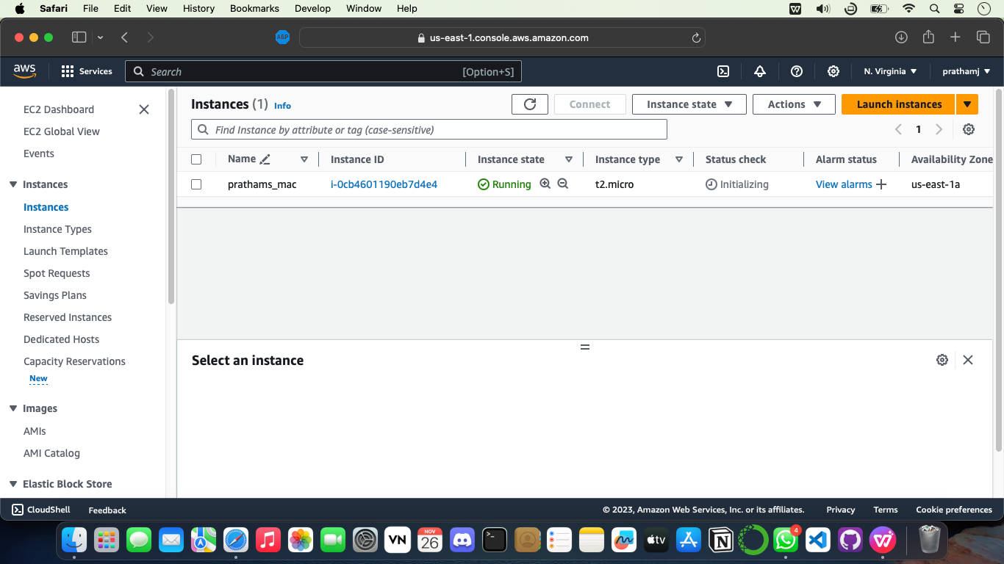

**Step 3 – Now we create instance and launch it, Now its time for Cloud9’s setup**

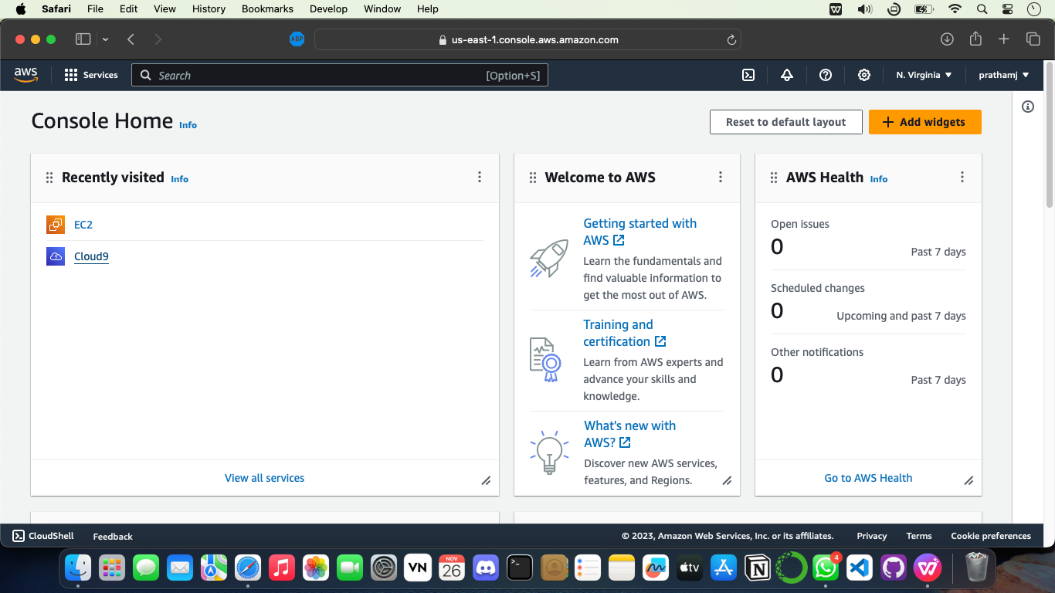

**Create New Enciornment**

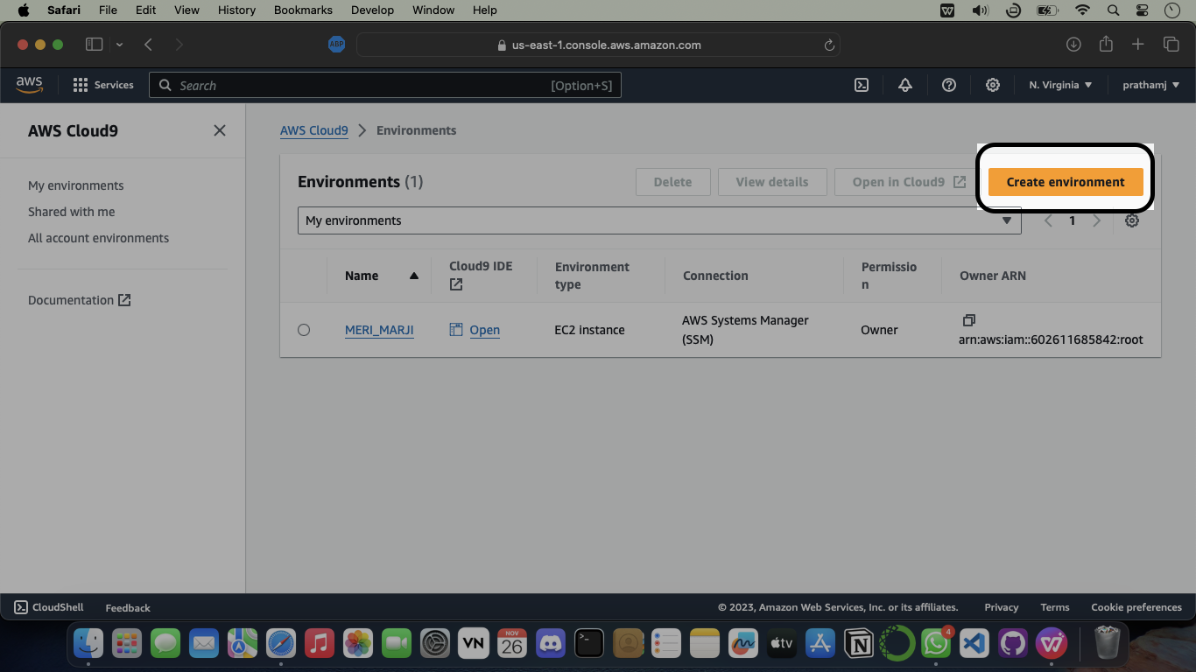

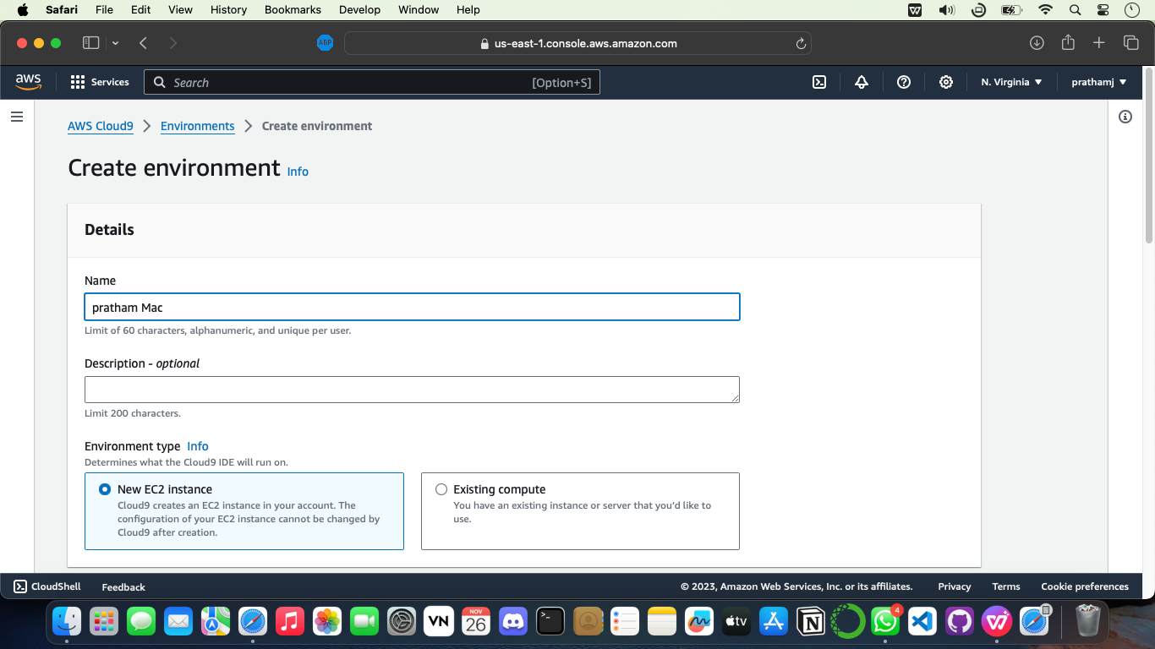

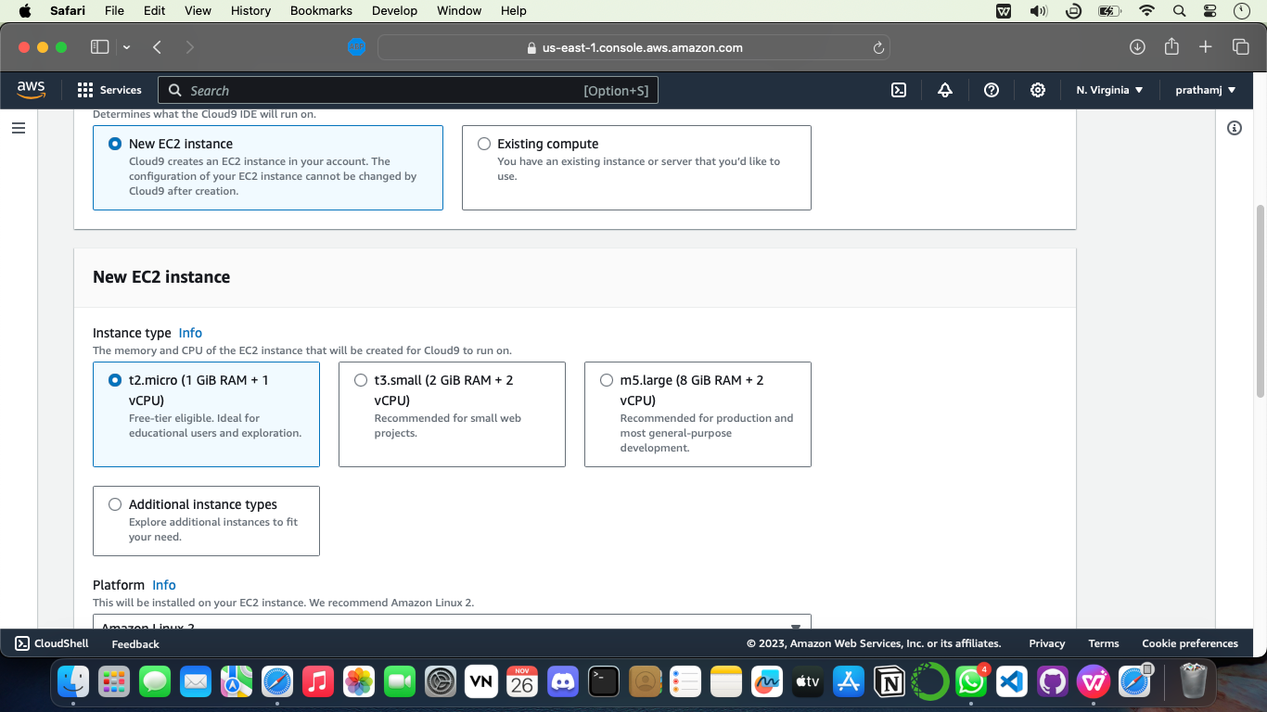

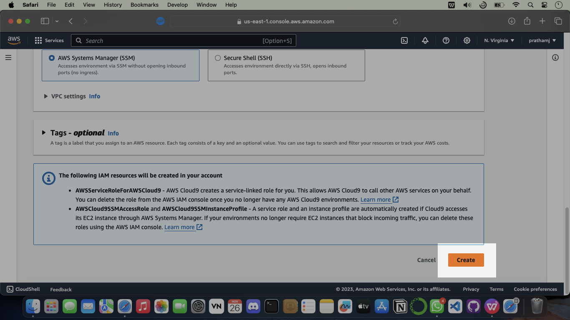

**Step 4. – Successfully Account is created**

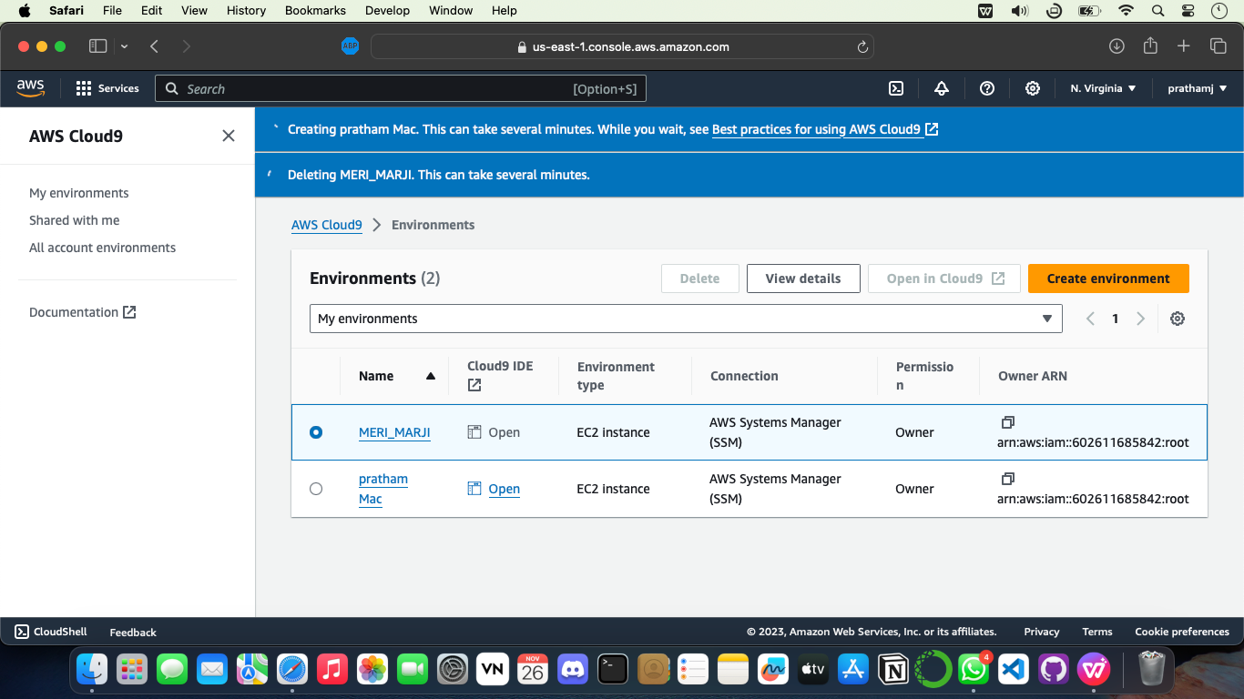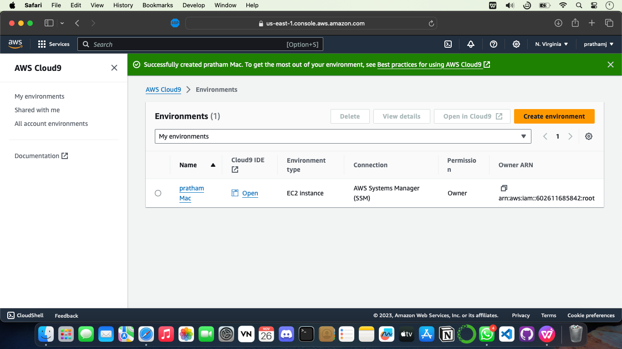

**Step 5 – After creating the cloud9 environment now we can start code in the environment**

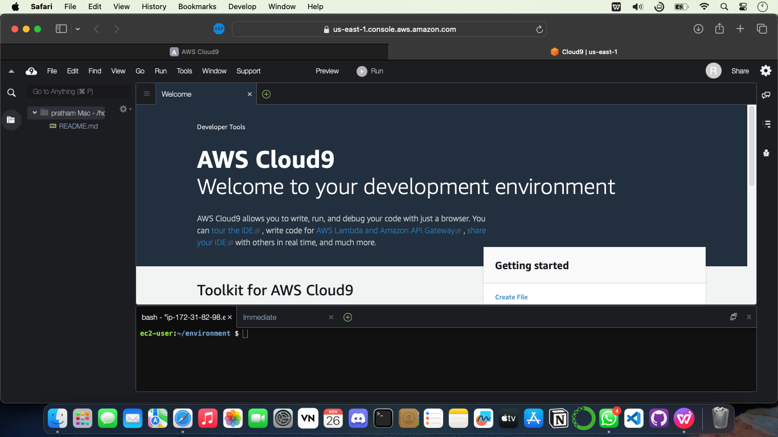

```npm install readline-sync```

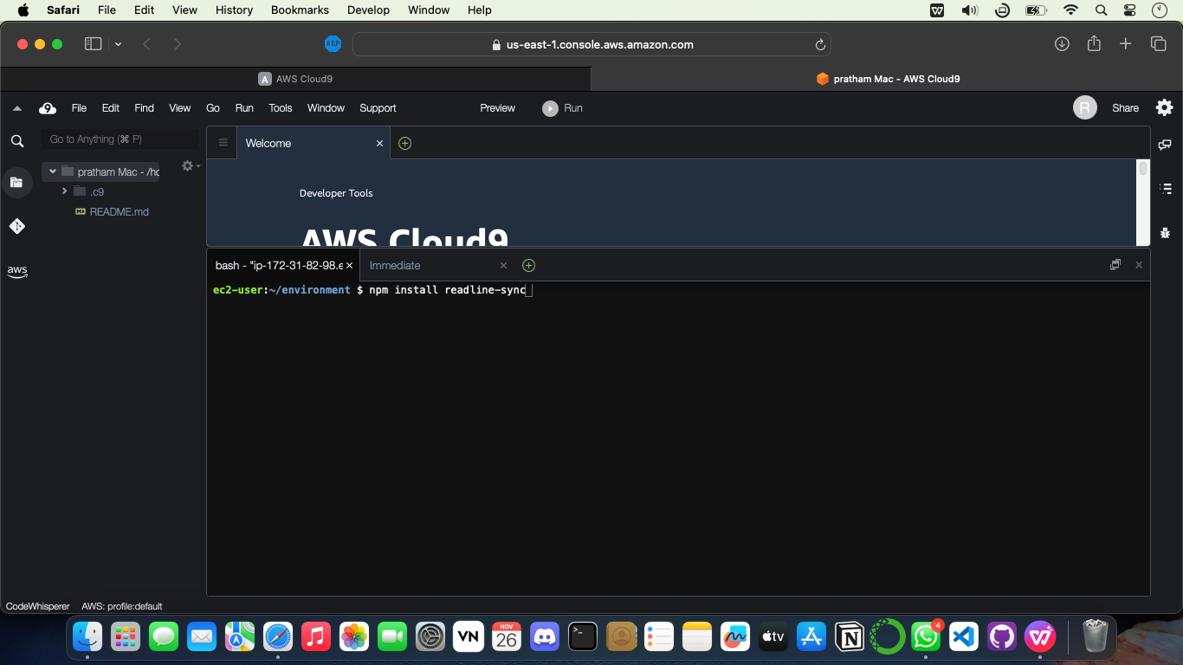

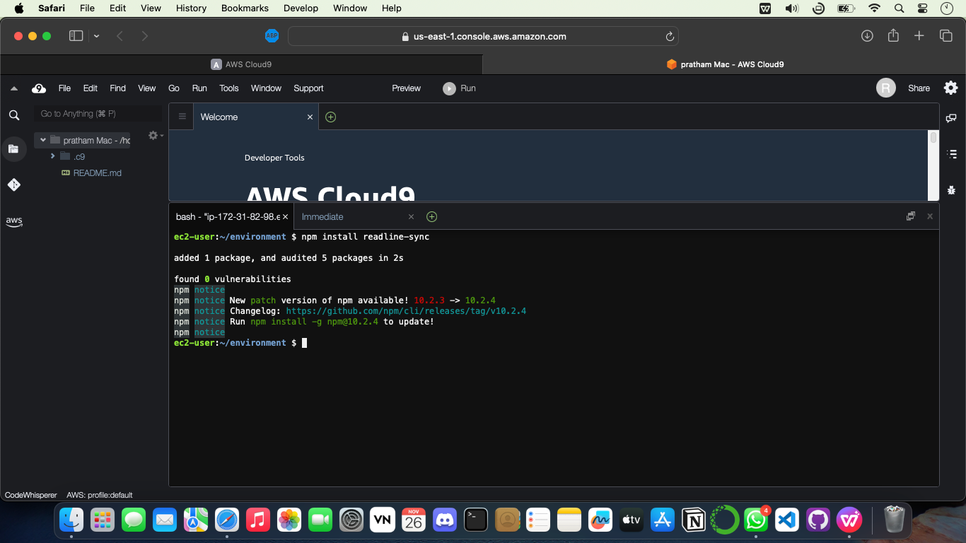

**Step 6. – Write the code in editor**

**python code for fibonacci series**

def generate_fibonacci(n):

fibonacci_series = []

a, b = 0, 1

count = 0

while count < n:

fibonacci_series.append(a)

a, b = b, a + b

count += 1

return fibonacci_series

# Generate Fibonacci series with 10 terms

fib_series = generate_fibonacci(10)

print("Fibonacci Series:")

print(fib_series)

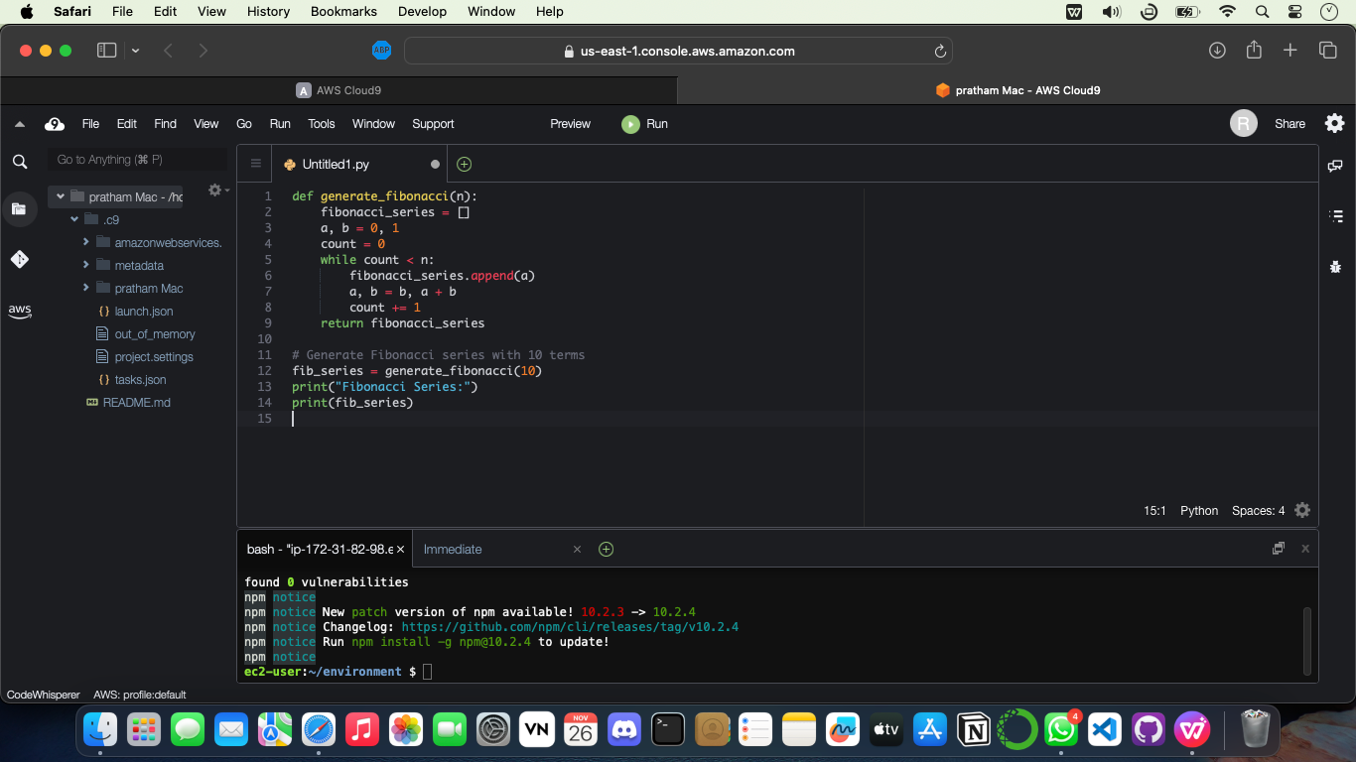

**Step 6. – Save the file and Run the code**

1. **Click on Run**
2. **Run Configuration**
3. **New Configuration**

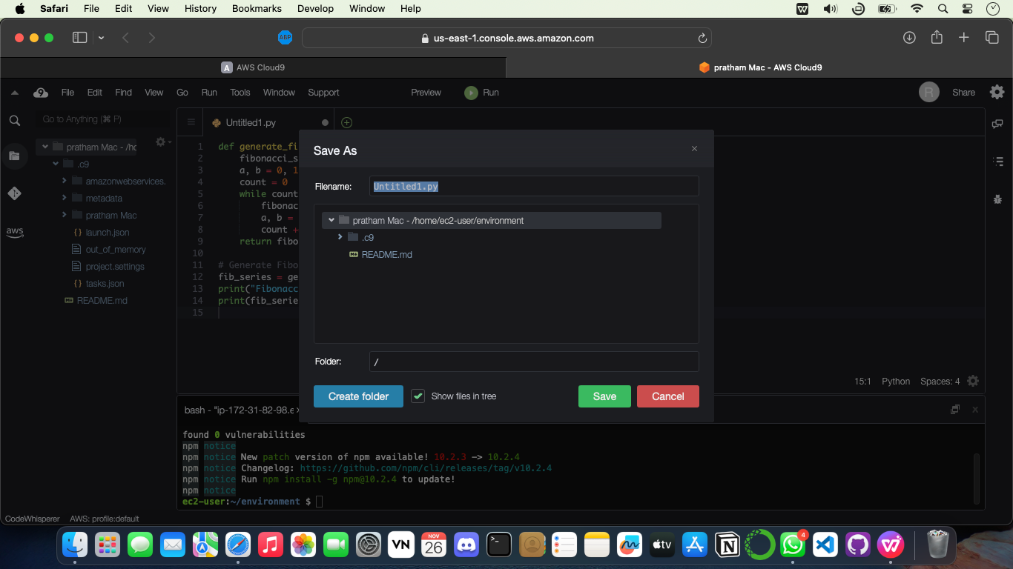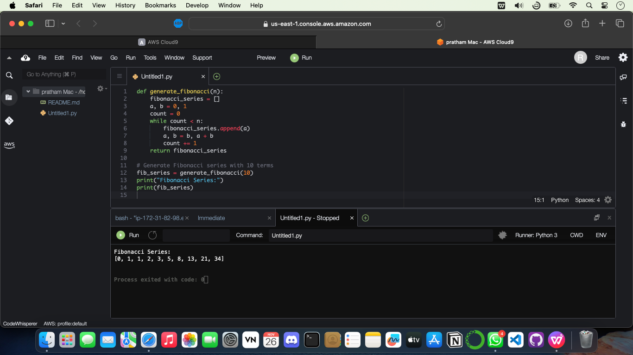

**In cloud9 you can write code in any languages like C++, C, python and many more.**

**Conclusion-**

Sucessfully learnt Working in Cloud9 to demonstrate different language.